Issues App (Main Modules)
- Incident Logging Module
Features:
- Incident posted(entered) by user
- Incident assigned to user by Super user (Help desk)
- Chat based on issue number.
- Incident reassignment by user to another user (union system global staff only).
- Comments Flow
  - RM to Technical person
  - RM to client
  - Technical person to technical person
User Case Diagram for Incident Logging Module

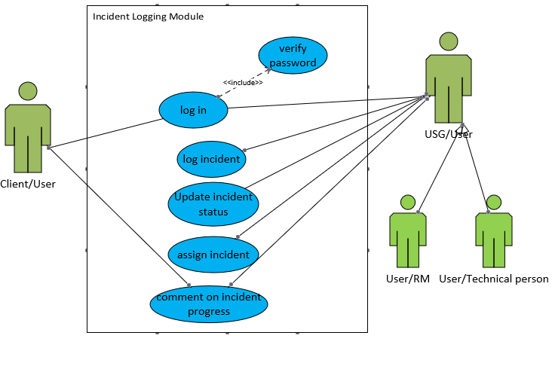

Table structure for incident.
Column | Type | Null | Default
Incident_Id | int(11) | No
Ticket_Id | varchar(100) | No
Company_Id | int(11) | Yes | NULL
Details | varchar(1000) | Yes | NULL
Summary | varchar(255) | Yes | NULL
Affected_Area | varchar(100) | Yes | NULL
Affected_Product | varchar(100) | Yes | NULL
Impact | int(200) | Yes | NULL
Urgency | int(11) | Yes | NULL
Priority | int(11) | Yes | NULL
Incident_Type | int(11) | Yes | NULL
Department | varchar(100) | Yes | NULL
Is_Image_Attached | int(11) | Yes | NULL
Image_Path | varchar(1000) | Yes | NULL
Person_Affected | varchar(100) | Yes | NULL
Affected_Person_Phone | varchar(100) | Yes | NULL
Affected_Person_Email | varchar(100) | Yes | NULL
Logged_By_Name | varchar(100) | Yes | NULL
Logged_By_Id | int(11) | Yes | NULL
Date_Logged | datetime | No
Assigned_To | int(11) | Yes | NULL
Assigned_Date | datetime | Yes | NULL
Resolved_By | int(11) | Yes | NULL
Resolved_Date | datetime | Yes | NULL
Closed_By | int(11) | Yes | NULL
Closed_Date | int(11) | Yes | NULL
Comment | int(11) | Yes | NULL
Resolution_Details | varchar(1000) | Yes | NULL
Resumption_Time | datetime | Yes | NULL
Type | varchar(100) | Yes | NULL
Status | int(50) | Yes | NULL
Resolution_Type | varchar(50) | Yes | NULL
root_cause | varchar(1000) | Yes | NULL
no_affected_users | varchar(50) | Yes | NULL
R_M_no | varchar(4) | Yes | NULL

Table structure for incident_type
Column | Type | Null | Default
Id | int(11) | No
Type | int(11) | No
Description | varchar(100) | No

Dump data for incident_type
1 | 1 | User Service Restoration
2 | 2 | User Service Request
3 | 3 | Infrastructure Restoration
4 | 4 | Infrastructure Event

Table structure for urgency
Column | Type | Null | Default
Id | int(11) | No
Type | int(11) | No
Description | varchar(100) | No

Dump data for urgency
1 | 1 | Critical/High
2 | 2 | Medium
3 | 3 | Low

- User Management Module
Features:
- Adding (creating) users based on company
- Updating user details
- Flagging User as active or inactive
Other additions:
- User details should pick from the hr system using an api
- Affected areas(app) – main & sub
  - Eg: x-100 sub: credit, approved
- Login sections(dashboard)
  - Department view
  - Personal (User) view
- Chat Flow
  - RM to Technical person
  - RM to client
  - Technical person to technical person
Use Case Diagram User Management Module
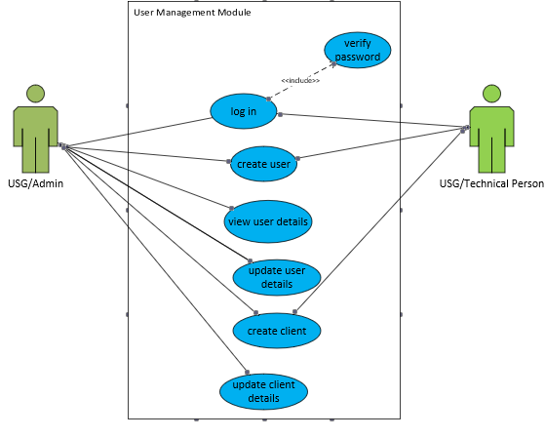

Table structure for users
Column | Type | Null | Default
Login_Id | int(11) | No
F_Name | varchar(100) | No
L_Name | varchar(100) | No
Full_Name | varchar(100) | No
Department | varchar(100) | No
Password | varchar(100) | No
Description | varchar(100) | No
Phone | varchar(20) | No
Email | varchar(100) | No
Company_Id | int(11) | No
Is_Client | int(11) | No
Is_Cc | int(11) | No
Is_Admin | int(11) | No
Last_Updated | datetime | No
Date_Created | datetime | No
City | varchar(100) | No
Country | varchar(100) | No
Dept_ID | int(11) | Yes | NULL
R_M | int(2) | No
working | int(4) | No | 1

Table structure for comments
Column | Type | Null | Default
Comment_Id | int(11) | No
Ticket_Id | varchar(100) | Yes | NULL
Posted_By | varchar(100) | Yes | NULL
Comment | varchar(1000) | Yes | NULL
Date_Posted | datetime | Yes | NULL
Is_Image_Attached | int(11) | Yes | NULL
Image_Path | varchar(200) | Yes | NULL

- Change Management Module
Features:
- Requesting for change (posting details)
- Updating change request details
- Saving change request details as draft
- Submitting change request for approval
- Approval of change request
o Approval should be done by Approvers (thus everyone in the approval chain) which includes
* Requestor’s Head of department.
* Daniel Eyeson(Dir. of Projects)
* Samuel Armarfio (Dir. of Q.A)
* Chris Armarfio (Managing Dir).
o Approval Timeline
* All changes must be approved before 48hours to implementation date
* If implementation date is due and not all have approved, the system
Must send the change to draft status.
o Change status
* Draft -> Review -> Approved -> scheduled -> completion
* Draft -> Review -> Rejected -> Draft
Draft is the status where change request is about to be submitted for review.
Review is the stage where the draft has been submitted and can be reviewed by
approvers whether to accept or reject change.
Scheduled means change request has been approved by all approvers and
Requester can proceed with actual development or implementation. It’s also
the window or period the change is active and must be done within the
implementation period.
Completion is the successful implementation of change and requester must
indicate end of implementation and mark change as completed.

- Client (Company) Management Module
Features:
- Adding(creating) client.
- Updating client details
- Flagging clients as active or inactive.
User Case Diagram for Client(Company) Management Module
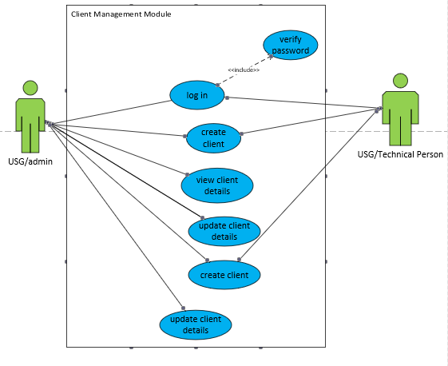

TABLE STRUCTURE FOR CLIENTS
Column | Type | Null | Default
Company_Id | int(11) | No
Company_Name | varchar(100) | No
Organization | varchar(100) | No
Department | varchar(100) | No
Region | varchar(100) | No
Site | varchar(100) | No
Phone | varchar(100) | No
Email | varchar(100) | No
Country | varchar(100) | No
Postal_Code | varchar(100) | No
Desc_ | varchar(100) | No
Logo_Id | varchar(100) | No
Date_Created | datetime | No
Last_Updated | datetime | No
r_m_login_id | int(11) | Yes | NULL

- Settings Module
Features:
- Creation of Code type
- Edit Code type
- Activation of code type
- Creation of Codesc
- Edit codesc
- Activation of codesc
Use Case Diagram for Settings Module
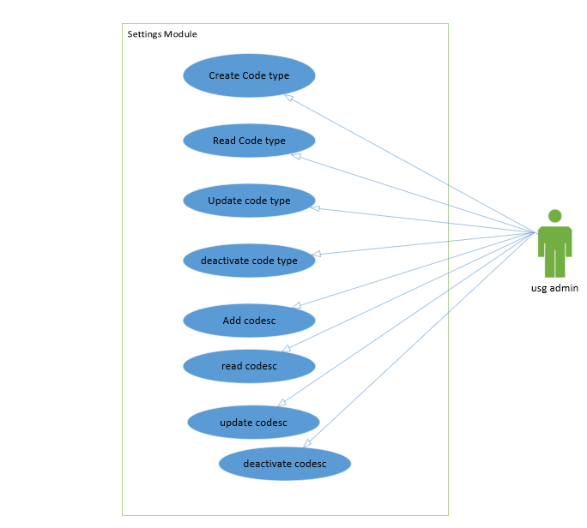

TABLE STRUCTURE FOR CODE TYPES
Column | Type | Null | Default | Extra
Id | int(11) | No | None | AUTO_INCREMENT
Code | Char(10) | No | None
Description | varchar(100) | No | None
Status | Smallint(6) | No | 1
Created_at | Timestamp | Yes | NULL
Updated_at | Timestamp | Yes | NULL

TABLE STRUCTURE FOR CODESC
Column | Type | Null | Default | Extra
Id | int(11) | No | None | AUTO_INCREMENT
Code_type_id | Int(11) | No | None
Code | Char(10) | No | None
Description | varchar(100) | No | None
Status | Smallint(6) | No | 1
Created_at | Timestamp | Yes | NULL
Updated_at | Timestamp | Yes | NULL

